Increasing Hire Heroes Donors by Geographic Locations and Social Media

# Author(s)

|  |  |
| --- | --- |
| * Zeeshan Ahmad * Virginia Commonwealth University * ahmadz2@vcu.edu * Information Systems * Undergraduate | * Heran Patel * Virginia Commonwealth University * patelh28@vcu.edu * Information Systems * Undergraduate |
| * Farres Maruf * Virginia Commonwealth University * maruffa@vcu.edu * Information Systems * Undergraduate | * Samuel Collier * Virginia Commonwealth University * colliersv@vcu.edu * Information Systems * Undergraduate |
| * Jonathan Rodriguez Ferrel * Virginia Commonwealth University * rodriguezfeja@vcu.edu * Information Systems * Undergraduate |  |

# Faculty Advisor

Joseph Cipolla, Information Systems, [jcipolla@vcu.edu](mailto:jcipolla@vcu.edu),

# Summary

After conducting data analysis of the Hire Heroes member and donor data, we are recommending that Hire Heroes implement an ‘average percentage of donors per state’ model as a template for which states should be the focal point of the social media campaign. Our recommendation for underperforming states is to implement a new and transformative social media approach in order to increase effectiveness of responsive donors.

# Problem and Motivation

The question we decided to address is, “Is there a geographic location within the US that most of our individual donors come from? Are there areas in the country we don't see any donors from? Does our social media posts or fundraisers calling for donations hit these areas with little to no donors?” According to the Audited Financial Statements on Hire Heroes’ website, they spent only $6,953 on Marketing and Development for Fundraising in 2017, shown in reference: 6. Their total expenses for Fundraising in 2017 was $368,936, that means less than 2% of their fundraising costs went to advertising. We chose this question because we believe that looking into the geographic and social media fundraising data can help Hire Heroes use their marketing budget more effectively and get significantly more donations. If Hire Heroes does not want to increase their budget, they could look at spending less money on the areas where they get a majority of their donors because they could be likely to donate regardless and use that money on the areas that have less donors. Or they could decide to spend less of the budget on the areas with little donors because they might not donate regardless of the marketing and the money could be used on the areas with more donors instead. If Hire Heroes decides to increase their fundraising marketing budget, they could just target the areas with little donors and see if the amount of donors increase in those areas. After choosing this question we looked into the data to determine if there are areas where most of Hire Heroes’ donors come from.

# Approach

Due to the problem addressed in the previous section, our focal point was to raise donations by marketing heavier in low donating states. In order to do this we first located all the necessary files that would be utilized in our analysis. This lead us to utilizing the Contact_Data.xls sheet to solve the questions at hand. Afterwards, in order to gain familiarity with the data, our team cross referenced the column headings with the Data Dictionary provided by Teradata University. Then, our team moved on to cleaning the data in order to ensure no dirty data was present. This process of thoroughly cleaning the data will be further detailed in the latter portion of this analysis. Once, we formulated our ideas and cleansed the data, we were able to formulate an approach to address the current issues related to donations.

The issue we were faced with was whether or not there was a certain geographical region where most of our Hire Hero Donors came from, specific areas where we do not see donors, and if Higher Heros social media outreach is effective. Our approach to solving this issue was to determine the recommended percentage of donors Hire Heroes could increase for each state. In order to tackle this, we first utilized the “MailingState” and “MailingCountry” in order to narrow down the data to only states and territories within the United States. Then we evaluated which columns were essential to our analysis, which is displayed in Reference 1. Next, we plugged this data set into Tableau in order to construct our various graphs. We displayed a geographic map showing donor density, a bar graph showing who opted out of communication mediums, and a table highlighting Hire Hero Members who are responsive to various communication forms. In order to implement this approach we needed to determine which data mining tools we were going to use for our analysis.

# Tools and Analytics

Choosing the right tools to analyze and clean the data was really fundamental as our goal was to get our results as accurate as we can. The main tools we used were Tableau Prep, Tableau Desktop and Microsoft Excel. First, we took the Contact_Data.csv file and we converted it to XLSX format to allow us to cleanse and add formulas within excel. Then, we made sure that all states in the “MailingState” column were in their abbreviated format. This was to ensure all states were accounted for correctly and accurately. Moving Forward, we then inserted the file into Tableau Prep which is where we noticed some anomalies such as blank abbreviations or any other states/abbreviations that showed locations outside the US , which we then removed. After cleaning the data we used Tableau Desktop and used the data shown in reference 1 to implement it into four graphs. As shown in Reference 2 we created a mapping hierarchy, so for tier 1 we had “MailingCountry” and for tier 2 we had “MailingState” then, we converted the Donor_C from Dimension to Measure. After plugging these variables into their respective locations we were given the donors per state. In reference 3 we used the same approach except we replaced the Donor_C for the ID giving us the sum of total members per state. For reference 4 we decided to use Excel to analyze any members who have opted out of communication with hire heroes, we made a pivot table where we put the states in the rows, and then we combined the fields who had opted out of fax, call and email and created a sum for those fields. Then we took those fields and populated the sum for each state as shown in Reference 4. In Reference 5 we decided to use Tableau Desktop and we focused on locating the responsive members per state. Our approach was, to convert the “Response_c “ to a dimension and then add “Count_ID” to the sheet. Next, we added “Response_c” under column and kept “MailingCountry” and “MailingState” as a row giving us the responsive members per state. This methodology produced very interesting results on Hire Heroes’ current situation and what should implemented in the future.

# Results:

When determining where the highest amount of donors come from, we compiled all individual donor data in Tableau and decided to use the mapping function to visualize the amount of donors in each state. As seen in Reference 2 most of the donations received were from the members that reside in Georgia. This was a surprising result of our findings due to Georgia only having in 9,127 members. In comparison to states like Texas (14,495 members) and California (13,044 members), which only had 452 and 541 donors respectively (See Reference 2 & 3). During our analysis we believed that solely looking at the number of individual donors would not accurately describe where our donors are coming from. In our opinion, the percentage of individual donors in relation to the amount of members that reside in that state is more accurate. For example a large state like California with a large amount of members, came in second for the largest amount of individual donors; however, when comparing California with Georgia, California only had 4.1% of its members donate while Georgia had 6.8% (See Reference 7). This may not seem like a large difference but if California had the same percentage of donors as Georgia did, they should have received 887 donations, nearly double the amount they are currently receiving. After looking at the amount of donors in percentages, we were surprised to find that Wisconsin had 30% of its members donating to Hire Heroes. This is an interesting finding because Wisconsin's high donor turnout suggests an exceeding passion for the Hire Heroes cause. Considering all things equal, if Wisconsin were to increase its member base, it is likely to outperform larger states such as California and Texas. Taking our findings a step further, we wanted to know the average percent of donors Hire Heroes should have for each state. To do this, we simply took the sum of the current percentages of each state and divided it by 54 (including states and territories) - this gave us a 5.3% average (See Reference 7). After finding the average, we applied that percentage to each state to see the amount of donors each state should be producing and then found the sum of the total donors. If Hire Heroes were to adopt this model, they would be able to increase their total amount of donors by 1,046 or in other words, a 16% increase in total donors.

Our approach for determining which states should be the target of the Hire Heroes social media efforts was to find out how many of the states are not meeting the 5.3% average that our team has recommended. To find this calculation, we created an if-then condition that checked the average percent of donors in each state and marked the number ‘1’ if the state was under the recommended percent and the number ‘0’ if the donors were above the percent. After implementing this condition, we simply took the sum of all the number ‘1’s that were listed; This gave us the total number of states that were not meeting the recommended percent of donors. Our calculations showed that 37 states were not meeting the criteria (See Reference 7). We believe these states should be the target of Hire Heroes social media campaign. We have decided that the states that are above the recommended percentage do not need to be targeted as heavily since Hire Heroes social media campaign is more of a passive approach for collecting donors in comparison to their other fundraising events. The objective of the social media campaign is to connect with members and raise awareness of new initiatives and goals for Hire Heroes. States with a higher percentage of donors are likely to already have a strong base of members who are engaged with the organization while the 37 states that we are recommending are likely to not have an as engaged member base.

The next aspect of our analysis was to determine whether or not Hire Heroes social media outreach was hitting these 37 states that are under the recommended percentage of donors. According to reference 5, Hire Heroes is reaching all of the donors, however, the presentation of this data from Teradata could be flawed. One aspect of this can be seen with the “Response_c” column. The column states donors who have either responded to the outreach, 1, or have not, 0. The downside to this is that a 0 could either mean they have been contacted by Hire Heroes and have not responded or they were not contacted at all but is still counted as a 0. Though this should into consideration for future analysis, our team has determined that the data is sufficient. Since Hire Heroes is able to reach all of its donors, we recommend that they update their social media campaign to a modern approach. Instead of utilizing methods such as fax, Hire Heroes should use social media sites; Facebook, Twitter, and Instagram. We determined that this update could increase the response rate of donors per state and increase the total donations.

# Reference:

**Reference 1:**

|  |  |  |
| --- | --- | --- |
| ***ID*** | **MailingSTATE** | **MailingCountry** |
| Donation_Amount__c | Donor_Status__c | DoNotCall, |
| Contact_Type__c | Special_Event__c | stayclassy__opt_in__c |
| Active__c, contact_history__c | stayclassy__date_of_last_donation__c | Donor_Type__c |
| Responsive__c, | Donor__c | LeadSource |
| HasOptedOutofEmail | HasOptedOutofEMail | Last Activity |
| Previous_HH_Client__c | Do_Not_Mail_old__c | stayclassy__sc_total_donated__c |
| Payment_Type_for_Donation__c | Payment_Received__c | Donor_Tracking_Color__c |
| Recurring_Donor__c | Recurring_Donor_Frequency__c |  |
|  |  |  |

**Reference 2: Donors Per State**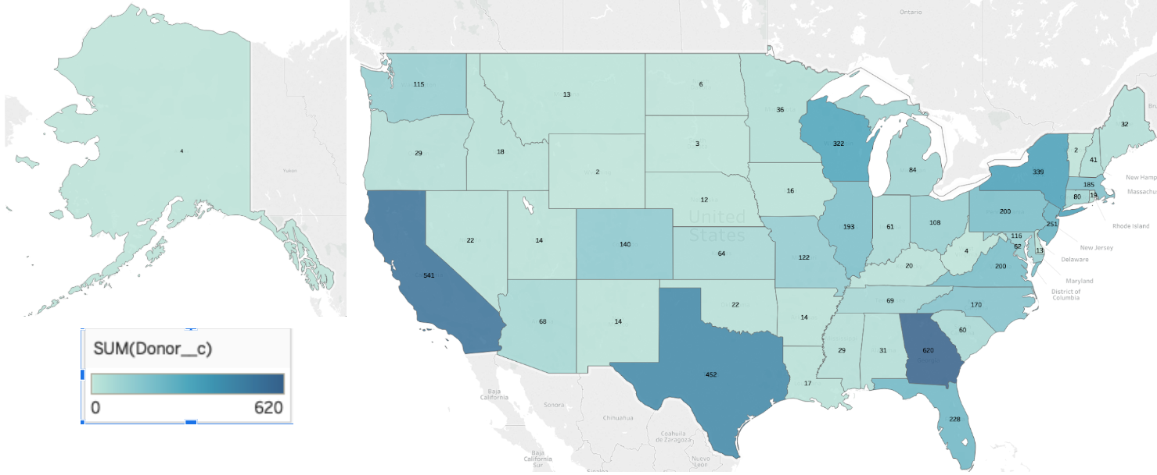

**Reference 3: Total Members Per State**

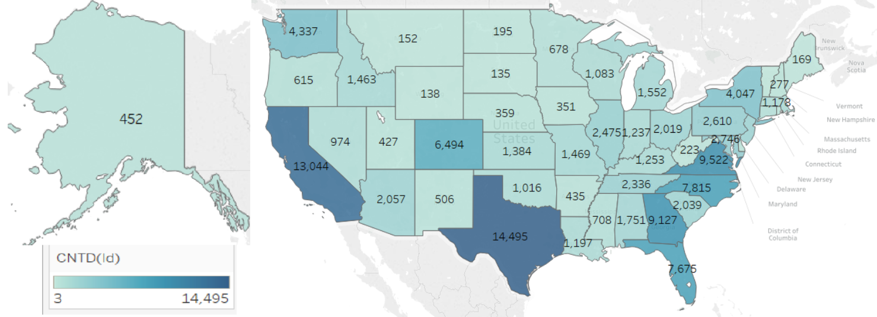

**Reference 4: Members Who Have Opted Out**

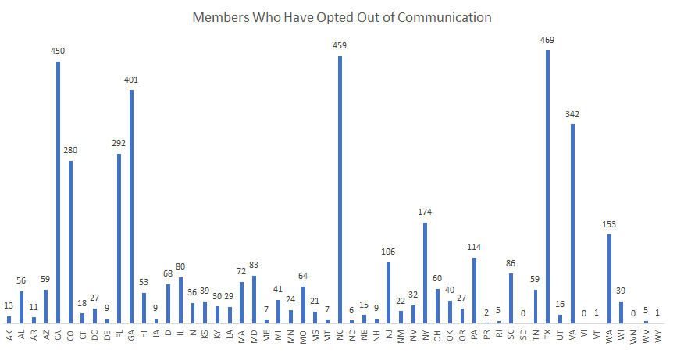

**Reference 5: Responsive Members Per State**

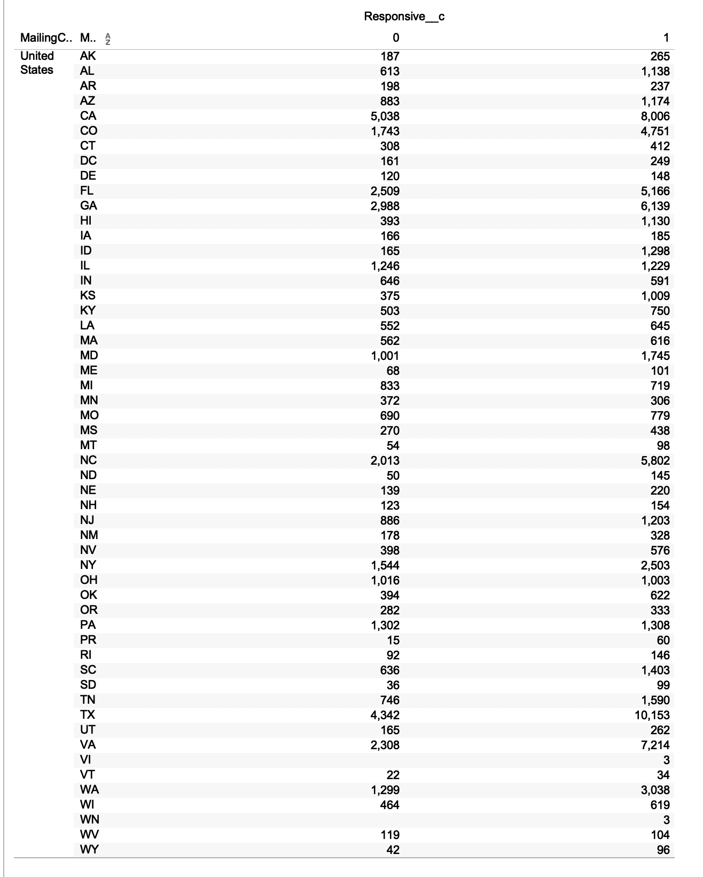

**Reference 6: Statements of Functional Expenses**

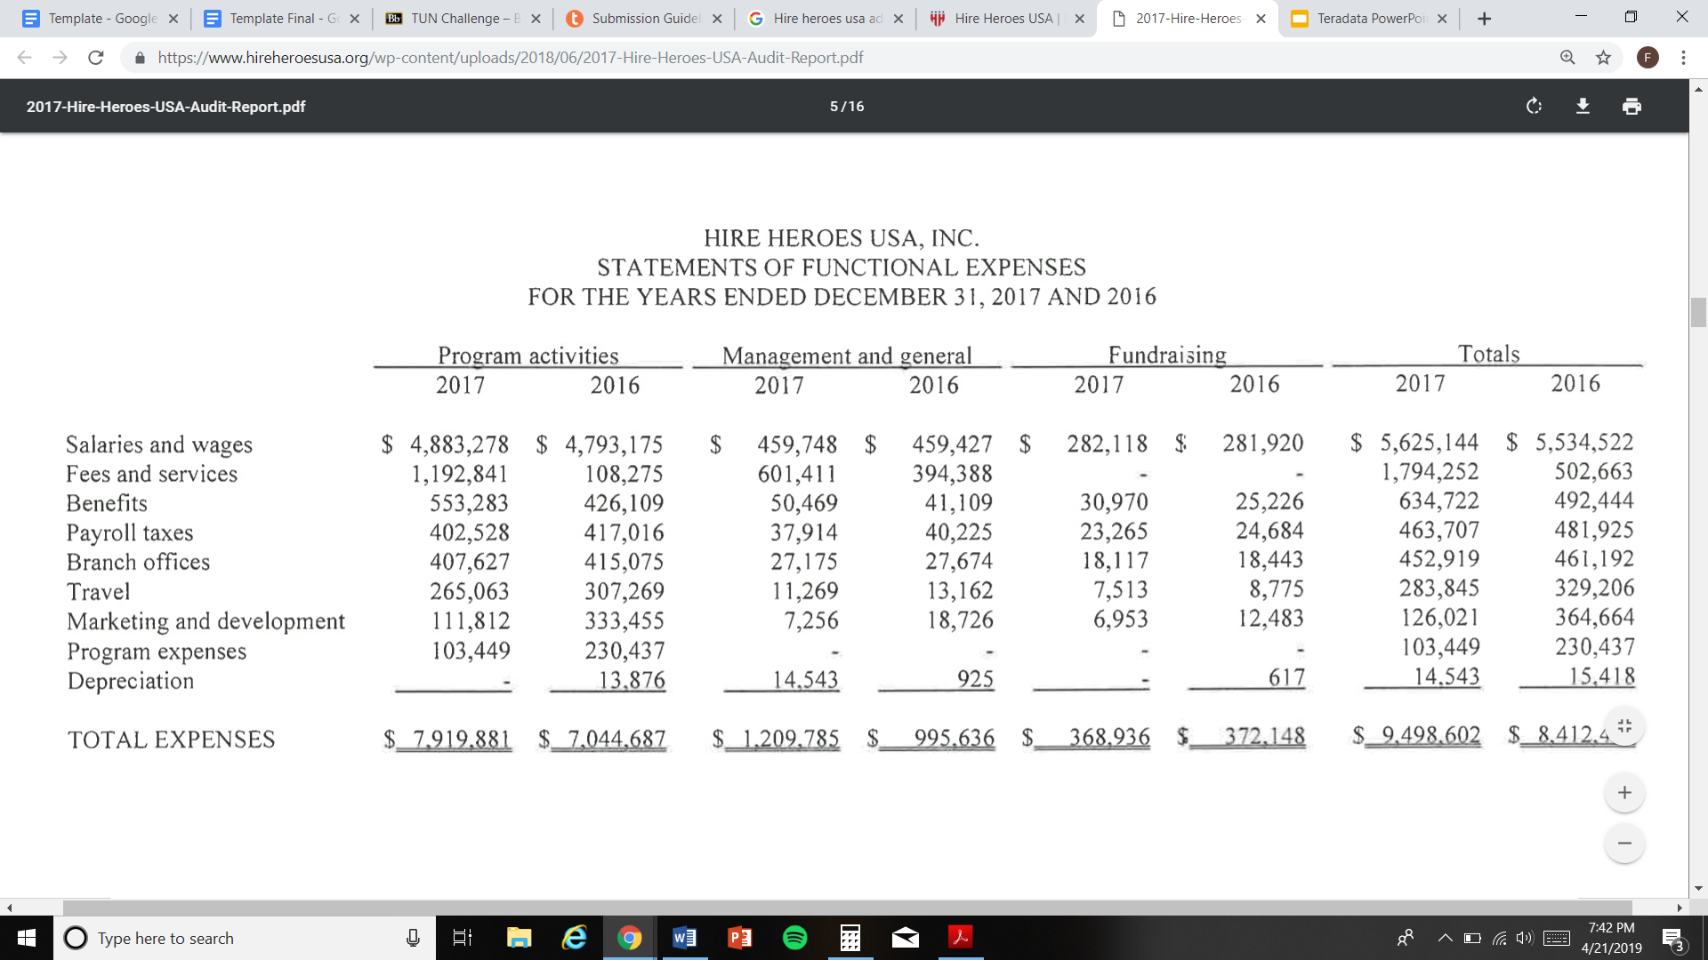

**Source:** [**https://www.hireheroesusa.org/wp-content/uploads/2018/06/2017-Hire-Heroes-USA-Audit-Report.pdf**](https://www.hireheroesusa.org/wp-content/uploads/2018/06/2017-Hire-Heroes-USA-Audit-Report.pdf)

Reference 7: Calculations for Average Amount of Recommended Donors

